Q1

Q2

Q3





Q4



Q5

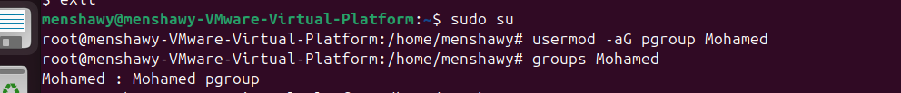

Q6

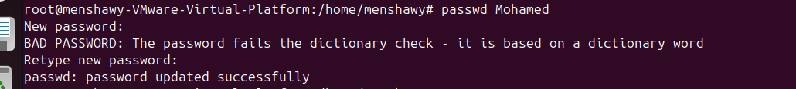

Q7





Q8



Q9

Q10





Q11





Q12

Q14 1)

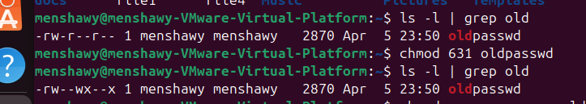

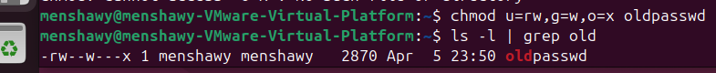

2)



3)

For files it is 666 (no execution by default)

For dirc it is 777

4)

Q15

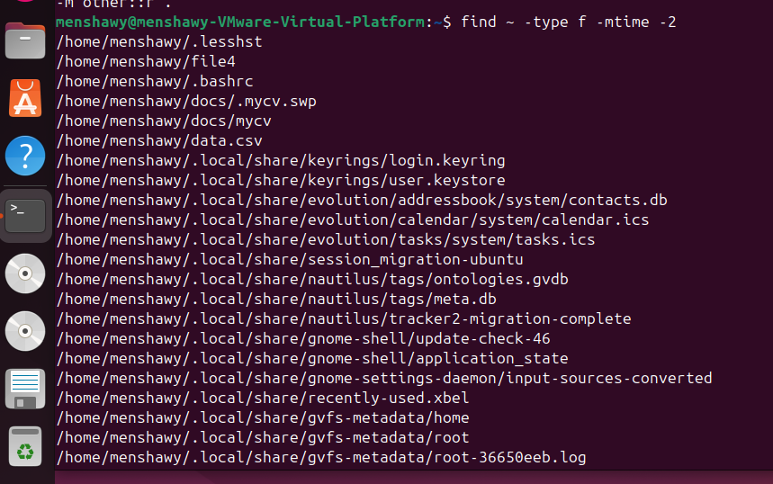

Q16

Q17

Q18

Q19

Q20

Q21

Q22

Q23

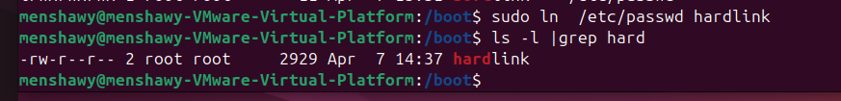

Yes we can.

By using sudo we can make this links and accessing the files that we don’t have permissions on.